**STEPS AND RESULT**

Our project is an attempt to recognize the Telugu text of an image and to convert into its Meaningful English speech. Here we have to upload the image and it will convert the Telugu text to its meaningful English speech.

* **Step 1 :** After Running the application can see the Template of the Project.

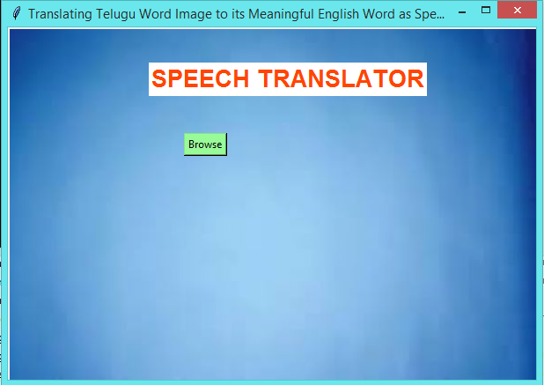

* **Step 2 :** When we click on Browse button to upload the image ,then we have to select on image from the location.

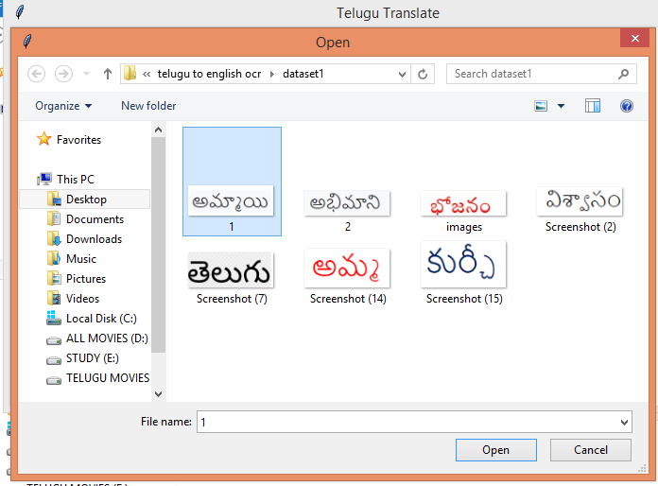

1.jpg

* The image that we are uploading should have the dimensions of upto 400 X 600.
* The image should be in the .png or .jpeg format.

If we does not select any image ,it will display an alert message as “Please select an image to translate” .

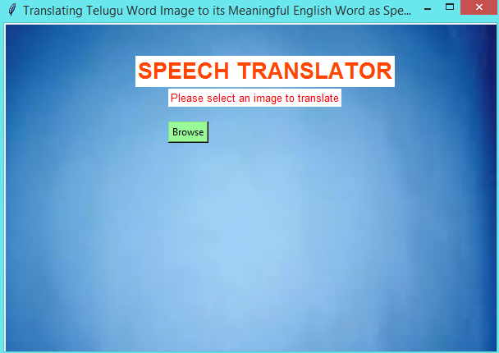

* **Step 3 :** After uploading the image, the application will enables the convert Button and a alert message is seen as “ Image uploaded successfully .Please click on convert button to translate.

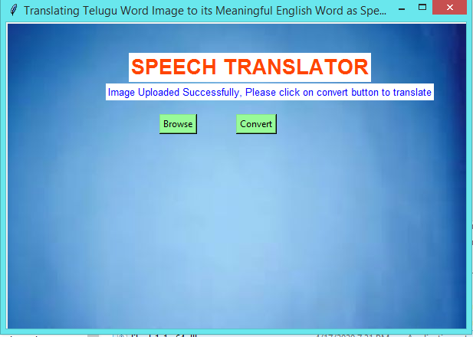

**Step 4 :** After processing the image, we can see the English word output of the input Telugu image and we can able to hear the voice of the output.

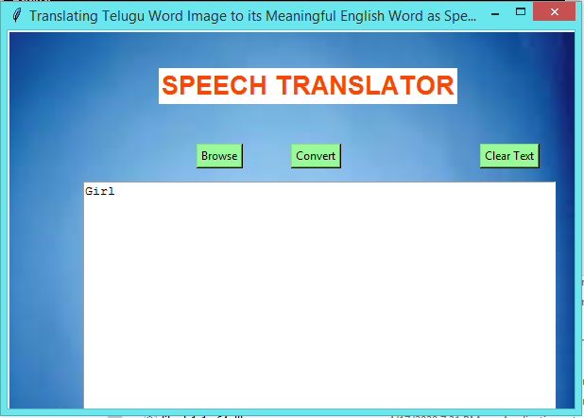

* The console of the project looks like:

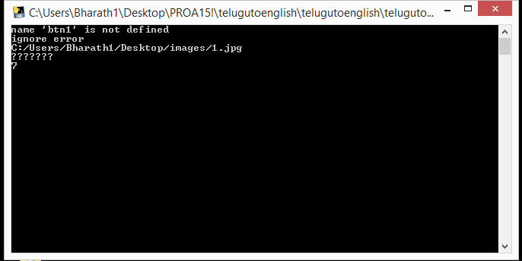

* **Step 5** :If any other type of file rather than .jpg or .png is attached  then we can see the alert message as “ file not supported”.

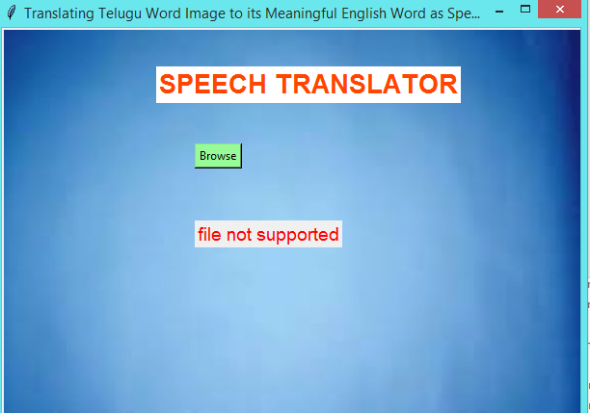

* **Step 6** :If the given image doesn't contain any Telugu word ,we can see the output as “Given image does not contain any Telugu word.

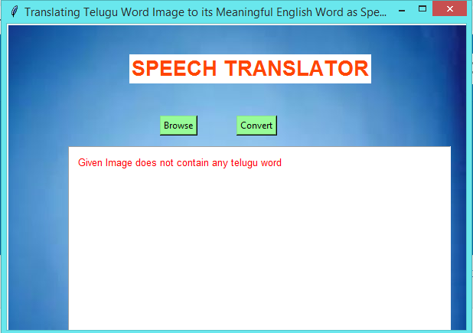

**List of packages and Libraries:**

* **Tkinter :**

Python offers multiple options for developing GUI (Graphical User Interface). Out of all the GUI methods, tkinter is the most commonly used method. It is a standard Python interface to the Tk GUI toolkit shipped with Python. Python with tkinter is the fastest and easiest way to create the GUI applications. Creating a GUI using tkinter is an easy task.

Importing tkinter is same as importing any other module in the Python code. Note that the name of the module in Python 2.x is ‘Tkinter’ and in Python 3.x it is ‘tkinter’.

* **Pytesseract :**

This package contains an OCR engine - libtesseract and a command line program - tesseract. Tesseract 4 adds a new neural net (LSTM) based OCR engine which is focused on online recognition, but also still supports the legacy Tesseract OCR engine of Tesseract 3 which works by recognizing character patterns. Compatibility with Tesseract 3 is enabled by using the Legacy OCR Engine mode (--oem 0). It also needs trained data files which support the legacy engine. Tesseract was originally developed at Hewlett-Packard Laboratories Bristol and at Hewlett-Packard Co, Greeley Colorado between 1985 and 1994, with some more changes made in 1996 to port to Windows, and some C++izing in 1998. In 2005 Tesseract was open sourced by HP. Since 2006 it has been developed by Google.

* **Googletrans :**

**Google Neural Machine Translation:**

Google Neural Machine Translation (GNMT) is a neural machine translation (NMT) system developed by Google and introduced in November 2016, that uses an artificial neural network to increase fluency and accuracy in Google Translate..

GNMT improves on the quality of translation by applying an example based (EBMT) machine translation method in which the system "learns from millions of examples. GNMT's proposed architecture of system learning was first tested on over a hundred languages supported by Google Translate. With the large end-to-end framework, the system learns over time to create better, more natural translations. GNMT is capable of translating whole sentences at a time, rather than just piece by piece. The GNMT network can undertake interlingual machine translation by encoding the semantics of the sentence, rather than by memorizing phrase-to-phrase translations.

The GNMT system is said to represent an improvement over the former Google Translate in that it will be able handle "zero-shot translation", that is it directly translates one language into another.

**Google Translate:**

That very idea was realized by Google engineers at the end of 2016. The architecture of NNs was built on the seq2seq model. The only exception is that between the encoder and decoder, there are eight layers of LSTM-RNN that have residual connections between layers with some tweaks for accuracy and speed. The main thing about this approach is that now the Google Translate algorithm uses only one system instead of a huge set for every pair of languages. The system requires a “token” at the beginning of the input sentence that specifies the language you’re trying to translate the phrase into. This improves translation quality and enables translations, even between two languages which the system hasn’t seen yet — a method termed “zero-shot translation.”

* **PYTTSX3**

Pyttsx3 is a text-to-speech conversion library in Python. Unlike alternative libraries, it works offline, and is compatible with both Python 2 and 3.Version 2.6 of pyttsx3 includes drivers for the following text-to-speech synthesizers.

**Using pyttsx3**

An application invokes the [pyttsx3.init()](https://pyttsx3.readthedocs.io/en/latest/engine.html#pyttsx3.init) factory function to get a reference to a pyttsx3.Engine instance. During construction,the engine initializes a [pyttsx3.driver **.** DriverProxy](https://pyttsx3.readthedocs.io/en/latest/drivers.html#pyttsx3.driver.DriverProxy) object responsible for loading a speech engine driver implementation from the [pyttsx3.drivers](https://pyttsx3.readthedocs.io/en/latest/drivers.html#module-pyttsx3.drivers) module. After construction, an application uses the engine object to register and unregister event callbacks; produce and stop speech; get and set speech engine properties; and start and stop event loops.

* **NumPy:**

NumPy stands for ‘Numerical Python’ or ‘Numeric Python’. It is an open source module of Python which provides fast mathematical computation on arrays and matrices. Since, arrays and matrices are an essential part of the Machine Learning ecosystem, NumPy along with Machine Learning modules like Scikit-learn, Pandas, Matplotlib, TensorFlow, etc. complete the Python Machine Learning Ecosystem.

NumPy provides the essential multi-dimensional array-oriented computing functionalities designed for high-level mathematical functions and scientific computation. NumPy can be imported into the notebook using

import numpy as np

NumPy’s main object is the homogeneous multidimensional array. It is a table with same type elements, i.e., integers or string or characters (homogeneous), usually integers. In NumPy, dimensions are called axes. The number of axes is called the rank.

* **OpenCV:**

OpenCV is an open source initiative, all are welcome to make contributions to this library. And it is the same for this tutorial also. So, if we find any mistake in this tutorial (whether it be a small spelling mistake or a big error in code or concepts, whatever), feel free to correct it. And that will be a good task for freshers who begin to contribute to open source projects. Just fork the OpenCV in GitHub, make necessary corrections and send a pull request to OpenCV. Open CV developers will check our pull request, give us important feedback and once it passes the approval of the reviewer, it will be merged to OpenCV. Then we become a open source contributor. Similar is the case with other tutorials, documentation etc.

As new modules are added to OpenCV-Python, this tutorial will have to be expanded. So those who know about a particular algorithm can write up a tutorial which includes a basic theory of the algorithm and a code showing basic usage of the algorithm and submit it to OpenCV

* **PIL :**

Python Imaging Library (abbreviated as PIL) (in newer versions known as Pillow) is a [free and open-source](https://en.wikipedia.org/wiki/Free_and_open-source_software) additional [library](https://en.wikipedia.org/wiki/Library_(computing)) for the [Python programming language](https://en.wikipedia.org/wiki/Python_(programming_language)) that adds support for opening, [manipulating](https://en.wikipedia.org/wiki/Image_editing), and saving many different [image file formats](https://en.wikipedia.org/wiki/Image_file_formats). It is available for [Windows](https://en.wikipedia.org/wiki/Microsoft_Windows), Mac OS X and [Linux](https://en.wikipedia.org/wiki/Linux). The latest version of PIL is 1.1.7, was released in September 2009 and supports Python 1.5.2–2.7, with [Python 3](https://en.wikipedia.org/wiki/Python_3) support to be released "later".

Development appears to be discontinued, with the last commit to the PIL [repository](https://en.wikipedia.org/wiki/Repository_(version_control)) coming in 2011. Consequently, a successor project called Pillow has [forked](https://en.wikipedia.org/wiki/Fork_(software_development)) the PIL repository and added Python 3.x support. This fork has been adopted as a replacement for the original PIL in [Linux distributions](https://en.wikipedia.org/wiki/Linux_distribution) including [Debian](https://en.wikipedia.org/wiki/Debian_GNU/Linux" \o "Debian GNU/Linux) and [Ubuntu](https://en.wikipedia.org/wiki/Ubuntu" \o "Ubuntu) (since [13.04](https://en.wikipedia.org/wiki/Ubuntu_version_history#1304)).